MA FIRST Tech Challenge Qualifier Video Upload Guidelines
Teams applying for the Control Award must submit a video to be considered. Judges would love to watch videos from all teams. Teams are encouraged to include a video of the robot executing a match.
All videos must be uploaded to VIMEO; No other video hosting sites will be accepted
- Videos must be viewable by the deadline midnight Tuesday before Judging Day (plan for upload times)
- The title of the video will be FTC Team number, Control or General
  - FTC00000_Control
  - FTC0000_General

When uploading your video please follow these steps to ensure all videos are uploaded correctly

  - Login to Vimeo at vimeo.com. Create an account if you do not have one.
  - Click on Upload a video

  - Select a file to upload and upload
  - If you would like your video to be public select Anyone otherwise select people with the password
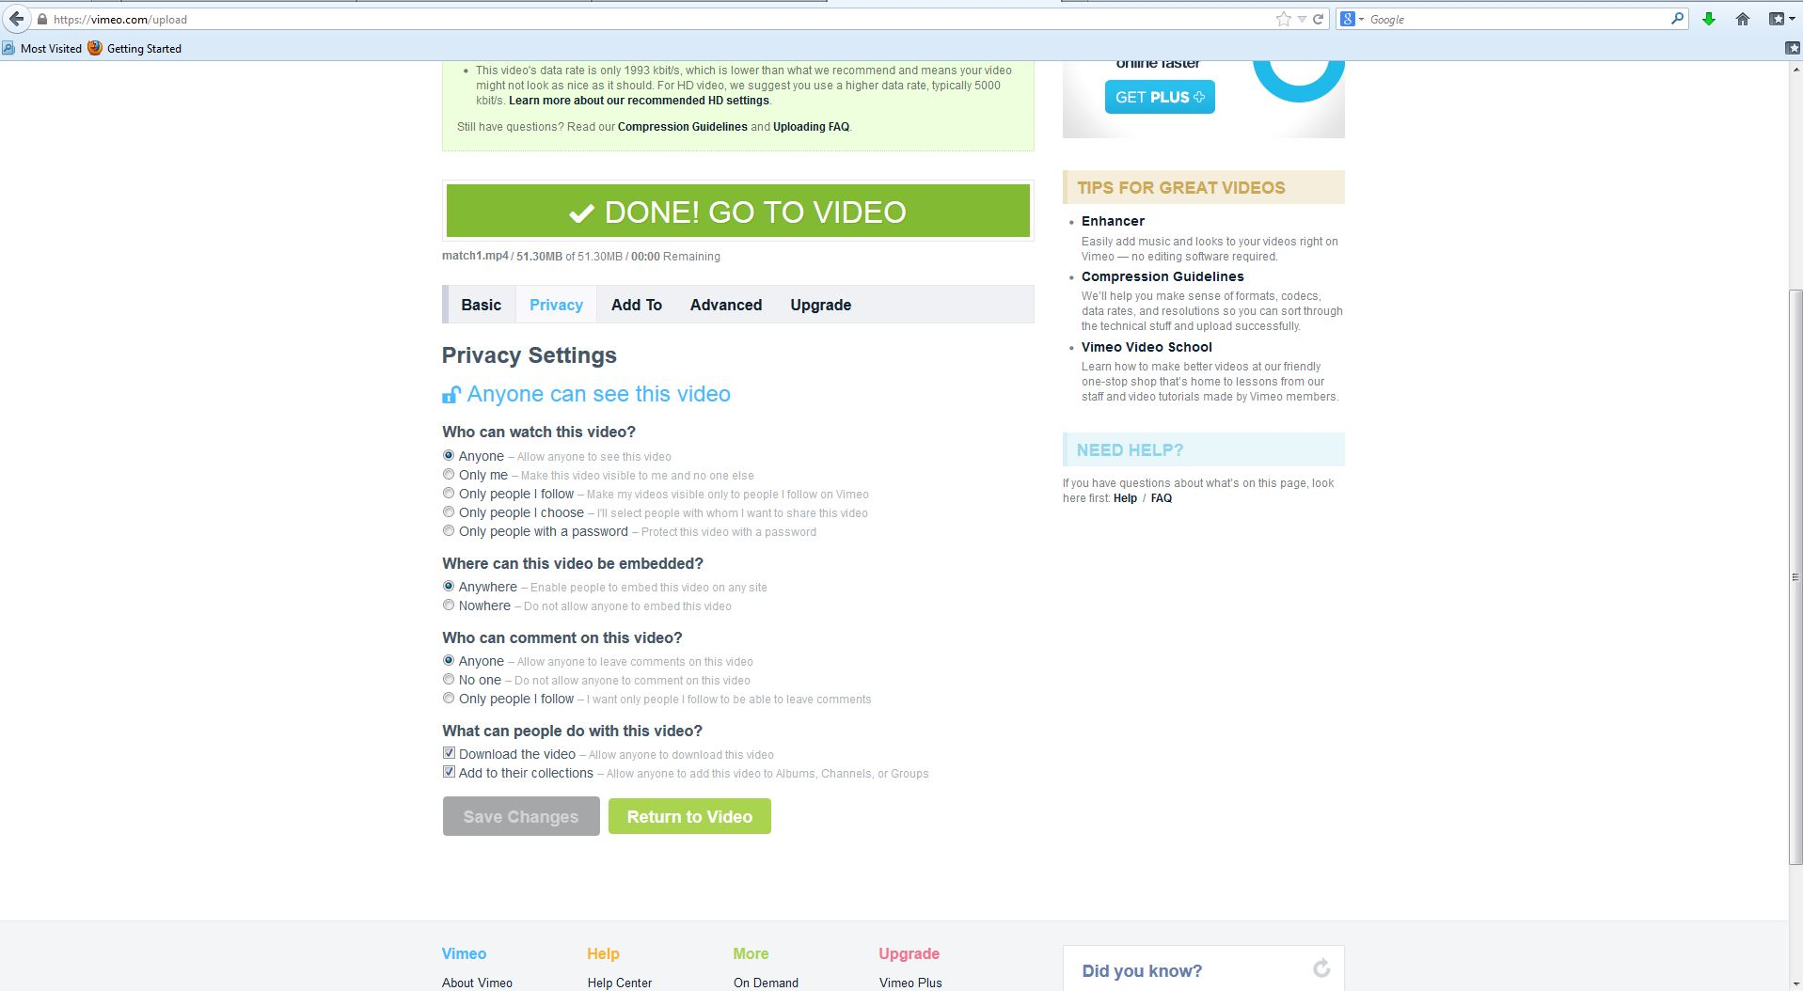
or
Send password

  - Be sure to include the URL of the Video in your email
  - If you have password protected the video, include the password in your email
  - Email the link to massftclinks@gmail.com with the subject your video name. You should also include the link of your Control video on the Control Award application
  - Do Not Share the video link as your submission
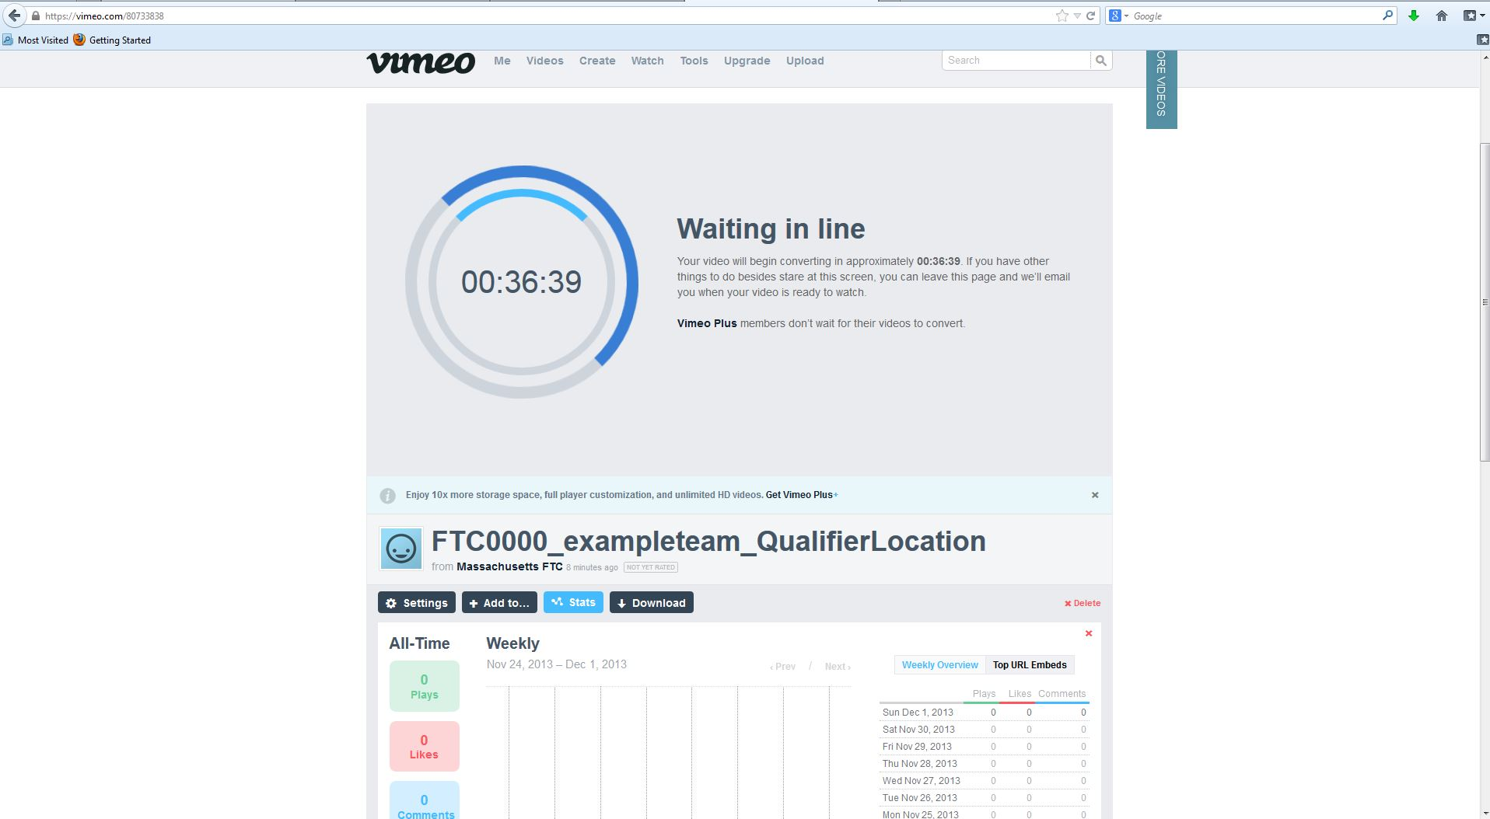
Email link to massftclinks@gmail.com
Email link to massftcvideo@gmail.com
Email Subject

FTC0000_Control

If you have questions please email massftc@gmail.com. You will receive an email confirmation when your video is received and reviewed. If you do not receive a confirmation within 24 hours send an email to massftc@gmail.com

We will complie the list of video links to give to the Judges. This will save the volunteers time and will help avoid the opportunity to overlook a video submission.

